

SELWYN COLLEGE CHAPEL, CAMBRIDGE

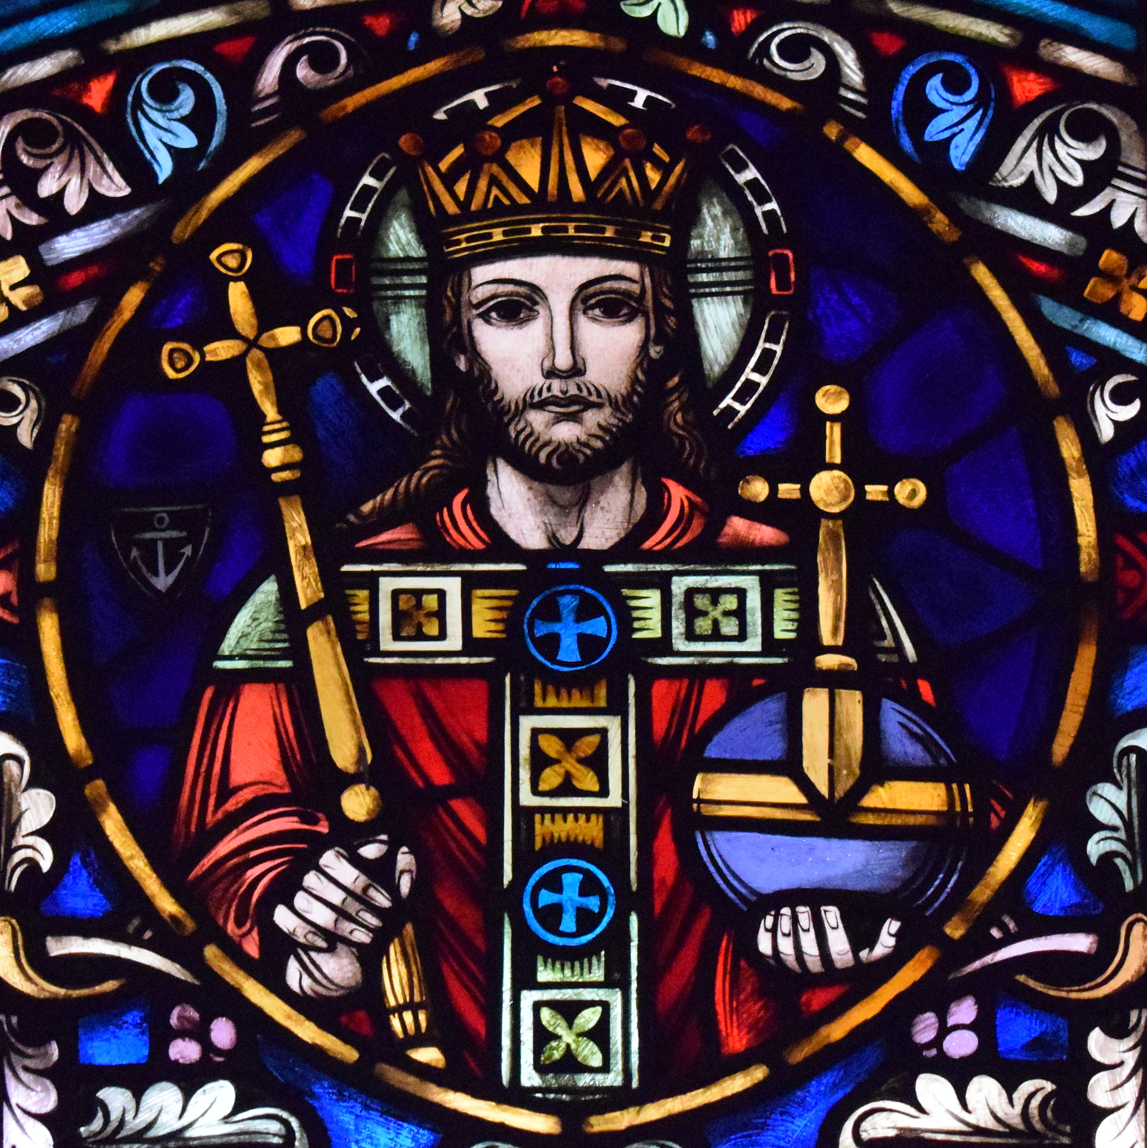

READINGS AND MUSIC FOR
THE FEAST OF CHRIST THE KING
Sunday 26 November 2023 at 6pm

Please note that this service is being livestreamed here:
https://www.youtube.com/watch?v=6mOeHcanTaw

cover image: Christ the King window in Saint Michael Church (Kalida, Ohio)

Common Worship: Services and Prayers for the Church of England,
material from which is included in this service,
is copyright © The Archbishops’ Council 2000.
Please stand at the entry of the procession.

¶ INTROIT The triumph of our King
words: adapted from the Exsultet
music: Sarah MacDonald SE 1999 (b. 1968)

Rejoice now, all ye heavenly angels; rejoice now, all creation;
resound, trumpet of salvation, and proclaim the triumph of our King!

Please remain standing.

¶ BIDDING PRAYER

Minister At the close of the Christian year, on the feast of Christ the King,
we proclaim with joy that above all other powers is set the humble strength of Christ Jesus our Lord. On this feast, at the threshold of Advent, when we prepare ourselves again to receive the one who comes to reign, let us renew in ourselves that vision of God’s perfect kingdom, which is the end of all our strivings and the consummation of God’s loving purposes for us.

In sorrow and penitence we confess our failures and shortcomings, and seek pardon for those sins which frustrate his redemptive purposes and hinder the advent of his reign of love.

And in prayer, praise, and song we give voice to the hope set forth in the Scriptures, that his kingdom shall come; and, as we prepare for that day to dawn upon us from on high, so we commend ourselves and the whole human family to his keeping.

May he guide us into the way of peace, give light to those who sit in darkness and the shadow of death, and kindle in us the fire of his love.

¶ CONFESSION

Minister Jesus says, ‘Repent, for the kingdom of heaven is close at hand.’
So let us turn away from sin and turn to Christ,
confessing our sins in penitence and faith.

Minister The kingdom is thine,
but we turn away from thy just rule:
Lord, have mercy.
All Lord, have mercy.
Minister The power is thine,
but we trust in our own power and strength:
Christ, have mercy.
All Christ, have mercy.

Minister The glory is thine,
but we fall short of the glory of God:
Lord, have mercy.
All Lord, have mercy.

¶ ABSOLUTION

Minister May the Father of all mercies cleanse you from your sins,
and restore you in his image to the praise and glory of his name,
through Jesus Christ our Lord.
All Amen.

¶ COLLECT FOR CHRIST THE KING

Minister Eternal Father, whose Son Jesus Christ
ascended to the throne of heaven that he might rule over all things
as Lord and King: keep the Church in the unity of the Spirit
and in the bond of peace, and bring the whole created order
to worship at his feet; who liveth and reigneth with thee,
in the unity of the Holy Spirit, one God, now and for ever.
All Amen.

HYMN Come thou long expected Jesus (NEH 3)
words: Charles Wesley (1707-1788)
music: CROSS OF JESUS – John Stainer (1840-1901)
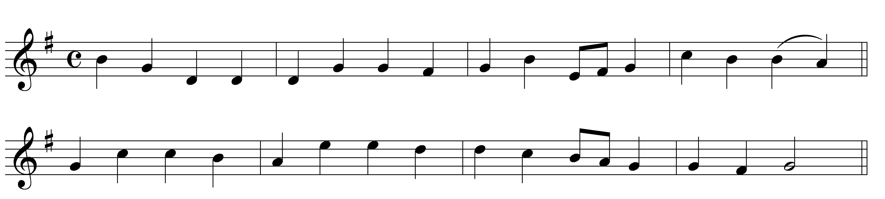

1 Come, thou long expected Jesus,  Born to set thy people free;  From our fears and sins release us,  Let us find our rest in thee. | 2 Israel’s strength and consolation,  Hope of all the earth thou art;  Dear desire of every nation,  Joy of every longing heart.
3 Born thy people to deliver,  Born a child and yet a King,  Born to reign in us forever,  Now thy gracious kingdom bring. | 4 By thine own eternal Spirit  Rule in all our hearts alone;  By thine all-sufficient merit,  Raise us to thy glorious throne.

Please sit.

¶ FIRST LESSON 2 Samuel 23: 1-7

The oracle of David, son of Jesse,
the oracle of the man whom God exalted,
the anointed of the God of Jacob,
the favourite of the Strong One of Israel:

The spirit of the Lord speaks through me,
his word is upon my tongue.
The God of Israel has spoken,
the Rock of Israel has said to me:
One who rules over people justly,
ruling in the fear of God,
is like the light of morning,
like the sun rising on a cloudless morning,
gleaming from the rain on the grassy land.

Is not my house like this with God?
For he has made with me an everlasting covenant,
ordered in all things and secure.
Will he not cause to prosper
all my help and my desire?
But the godless are all like thorns that are thrown away;
for they cannot be picked up with the hand;
to touch them one uses an iron bar
or the shaft of a spear.
And they are entirely consumed in fire on the spot.

Please stand.
¶ PSALM 93 Dominus regnavit

Cantor 1 THE LORD is King and hath put on glorious ap-pa-rel :
the Lord hath put on his apparel and gird-ed him-self withˆstrength.

Full 2 He hath made the round world so sure (---) :
that it can-not beˆmoved.

Cantor 3 Ever since the world began hath thy seat been pre-pared (---) :
thou art from ev-er-last-ing.

Full 4 The floods are risen O Lord, *
the floods have lift up their voice (---) :
the floods lift up theirˆwaves.

Cantor 5 The waves of the sea are mighty and rage hor-riˆbly :
but yet the Lord who dwelleth on high is might-iˆer.

Full 6 Thy testimonies O Lord are very sure (---) :
holiness becometh thine house for e-ver.

Cantor Glory be to the Father and to the Son (---) :
and to the Ho-lyˆGhost;

Full As it was in the beginning is now and ever shall be :
world with-out end A-men.

Please sit.

¶ SECOND LESSON Daniel 7: 9-10, 13-14

As I watched,
thrones were set in place,
and an Ancient One took his throne;
his clothing was white as snow,
and the hair of his head like pure wool;
his throne was fiery flames,
and its wheels were burning fire.
A stream of fire issued
and flowed out from his presence.
A thousand thousand served him,
and ten thousand times ten thousand stood attending him.
The court sat in judgement,
and the books were opened.
As I watched in the night visions,
I saw one like a human being
coming with the clouds of heaven.
And he came to the Ancient One
and was presented before him.
To him was given dominion
and glory and kingship,
that all peoples, nations, and languages
should serve him.
His dominion is an everlasting dominion
that shall not pass away,
and his kingship is one
that shall never be destroyed.

¶ ANTHEM Let all the world
words: Antiphon (I) – George Herbert (1593-1633)
music: Ralph Vaughan Williams (1872-1958) (from Five Mystical Songs)

Let all the world in every corner sing,
My God and King!
The heav’ns are not too high,
His praise may thither fly;
The earth is not too low,
His praises there may grow.

Let all the world in every corner sing,
My God and King!
The church with psalms must shout:
no door can keep them out.
But, more than all, the heart
must bear the longest part.
Let all the world in every corner sing,
My God and King!
¶ THIRD LESSON Philippians 2: 5-11

Let the same mind be in you that was in Christ Jesus,
who, though he was in the form of God,
did not regard equality with God
as something to be exploited,
but emptied himself,
taking the form of a slave,
being born in human likeness.
And being found in human form,
he humbled himself
and became obedient to the point of death
even death on a cross.
Therefore God also highly exalted him
and gave him the name
that is above every name,
so that at the name of Jesus
every knee should bend,
in heaven and on earth and under the earth,
and every tongue should confess
that Jesus Christ is Lord,
to the glory of God the Father.

¶ ANTHEM Bethlehem Down
words: Bruce Blunt (1899-1957)
music: Peter Warlock (1894-1930)

When He is King we will give him the King’s gifts,
Myrrh for its sweetness, and gold for a crown,
“Beautiful robes”, said the young girl to Joseph
Fair with her first-born on Bethlehem Down.
Bethlehem Down is full of the starlight
Winds for the spices, and stars for the gold,
Mary for sleep, and for lullaby music
Songs of a shepherd by Bethlehem fold.
When He is King they will clothe Him in grave-sheets,
Myrrh for embalming, and wood for a crown,
He that lies now in the white arms of Mary
Sleeping so lightly on Bethlehem Down.
Here He has peace and a short while for dreaming,
Close-huddled oxen to keep Him from cold,
Mary for love, and for lullaby music
Songs of a shepherd by Bethlehem fold.

¶ FOURTH LESSON Matthew 28: 16-end

Now the eleven disciples went to Galilee, to the mountain to which Jesus had directed them. When they saw him, they worshipped him; but some doubted. And Jesus came and said to them, ‘All authority in heaven and on earth has been given to me. Go therefore and make disciples of all nations, baptising them in the name of the Father and of the Son and of the Holy Spirit, and teaching them to obey everything that I have commanded you. And remember, I am with you always, to the end of the age.’

¶ ANTHEM E’en so, Lord Jesus, quickly come
words: based on Revelation 22, adapted by Ruth Manz (1919-2008)
music: Paul Manz (1919-2009)

Peace be to you and grace from him
Who freed us from our sins,
Who loved us all and shed his blood
That we might saved be.

Sing holy, holy to our Lord,
The Lord, Almighty God,
Who was and is and is to come;
Sing holy, holy, Lord!

Rejoice in heaven, all ye that dwell therein,
Rejoice on earth, ye saints below,
For Christ is coming, is coming soon,
For Christ is coming soon!

E’en so, Lord Jesus, quickly come,
And night shall be no more;
They need no light nor lamp nor sun,
For Christ will be their All!
Please stand.

¶ HYMN Eternal Monarch, King most high (NEH 128)
words: Latin c. 5th century, tr. J. M. Neale (1818-1866)
music: GONFALON ROYAL – Percy Buck (1871-1947)

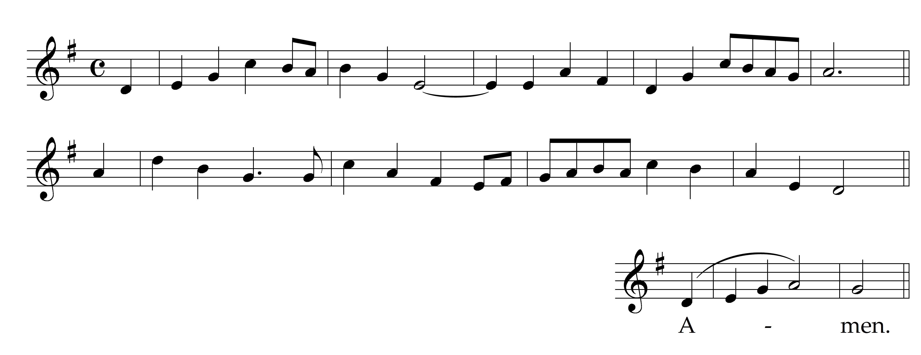

1 Eternal Monarch, King most high,
Whose blood hath brought redemption nigh,
By whom the death of Death was wrought
And conquering grace’s battle fought:

2 Ascending to the throne of might,
And seated at the Father’s right,
All power in heaven is Jesu’s own,
That here his manhood had not known.

3 Yea, angels tremble when they see
How changed is our humanity;
That flesh hath purged what flesh had stained,
And God, the flesh of God, hath reigned.

4 Be thou our joy and strong defence,
Who art our future recompense:
So shall the light that springs from thee
Be ours through all eternity.

5 O risen Christ, ascended Lord,
All praise to thee let earth accord,
Who art, while endless ages run,
With Father and with Spirit One.
Amen.
Please sit.
¶ FIFTH LESSON Revelation 19: 11-16

Then I saw heaven opened, and there was a white horse! Its rider is called Faithful and True, and in righteousness he judges and makes war. His eyes are like a flame of fire, and on his head are many diadems; and he has a name inscribed that no one knows but himself. He is clothed in a robe dipped in blood, and his name is called The Word of God. And the armies of heaven, wearing fine linen, white and pure, were following him on white horses. From his mouth comes a sharp sword with which to strike down the nations, and he will rule them with a rod of iron; he will tread the wine press of the fury of the wrath of God the Almighty. On his robe and on his thigh he has a name inscribed, ‘King of kings and Lord of lords’.

¶ ANTHEM Let all mortal flesh keep silence
words: 4th-century Liturgy of St James
music: Edward Bairstow (1874-1946)

Let all mortal flesh keep silence
and stand with fear and trembling,
and lift itself above all earthly thought.
For the King of kings and Lord of lords,
Christ our God, cometh forth to be our oblation,
and to be given for Food to the faithful.
Before Him come the choirs of angels
with every principality and power;
the Cherubim with many eyes,
and wingèd Seraphim, who veil their faces
as they shout exultingly the hymn: Alleluia!

Please sit or kneel.

¶ PRAYERS

The following petitions may be used:

Lord, in thy mercy: (or) Lord, hear us:
Hear our prayer. Lord, graciously hear us.
The prayers end with the Lord’s Prayer

All Our Father,
who art in heaven,
hallowed be thy name;
thy kingdom come;
thy will be done;
on earth as it is in heaven.
Give us this day our daily bread.
And forgive us our trespasses,
as we forgive those who trespass against us.
And lead us not into temptation;
but deliver us from evil.
For thine is the kingdom,
the power and the glory,
for ever and ever. Amen.

Please stand.

¶ HYMN Christ triumphant, ever reigning (SP 280)
words: Michael Saward (b. 1932)
music: GUITING POWER – John Barnard SE 1967 (b. 1948)

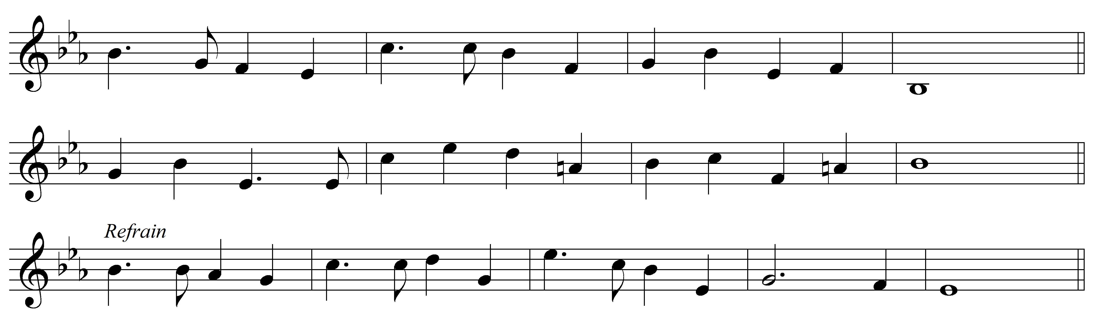

1  Christ triumphant, ever reigning,  Saviour, Master, King!  Lord of heaven, our lives sustaining,  hear us as we sing:  Yours the glory and the crown,  the high renown, the eternal name. | 2  Word incarnate, truth revealing,  Son of Man on earth!  power and majesty concealing  by your humble birth:  Yours the glory...
3  Suffering servant, scorned, ill-treated,  victim crucified!  death is through the cross defeated,  sinners justified:  Yours the glory... | 4  Priestly king, enthroned for ever  high in heaven above!  sin and death and hell shall never  stifle hymns of love:  Yours the glory...
5
So, our hearts and voices raising
through the ages long,
ceaselessly upon you gazing,
this shall be our song:
Yours the glory...

¶ BLESSING

Minister Christ our King
make you faithful and strong to do his will,
that you may reign with him in glory;
and the blessing of God Almighty,
the Father, the Son, and the Holy Ghost,
be amongst you and remain with you always.
All Amen.

Please remain standing as the procession departs.

¶ VOLUNTARY Alleluyas – Simon Preston (1938-2022)

CHAPEL NOTICES

Please join us for drinks in the Old SCR after the service before Chapel Supper.

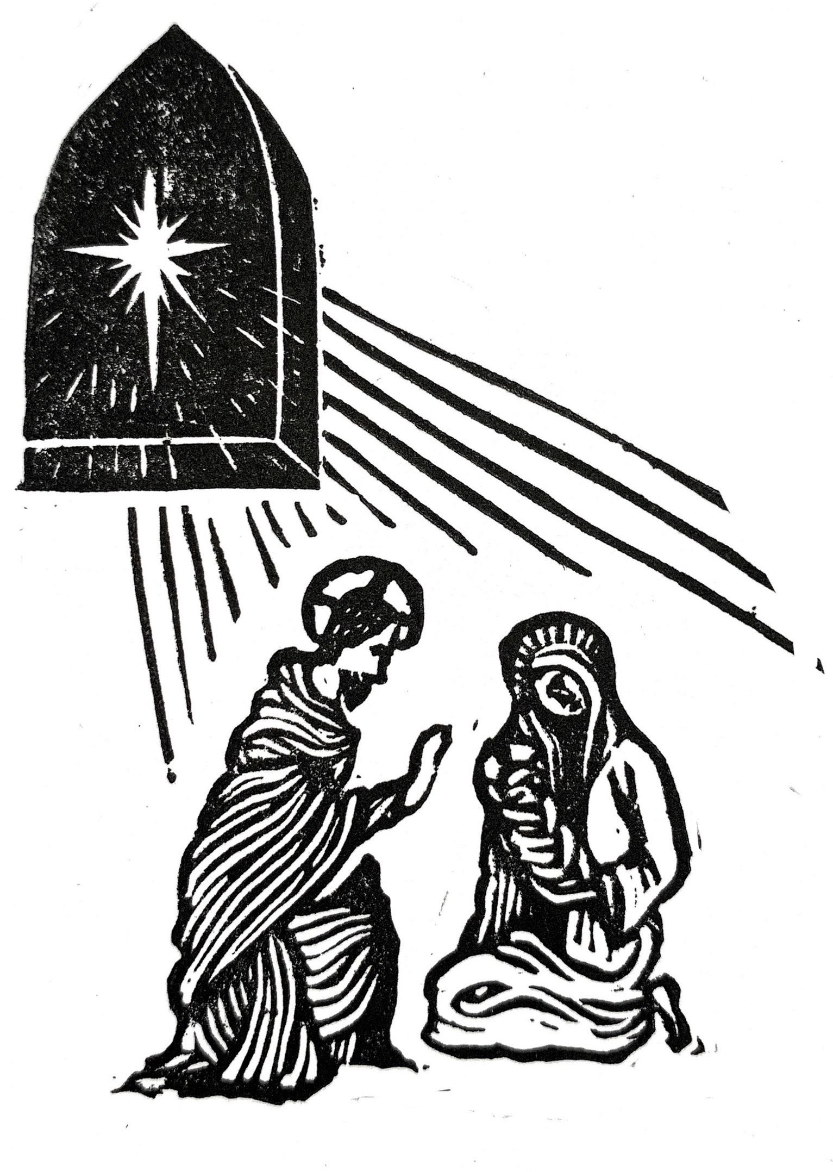
CHRISTMAS SERVICES
It’s not too late to book tickets for you and your guests to our wonderful services of lessons and carols here in Selwyn Chapel! If you are a college member or on the chapel mailing list you will have received an email telling you how to do this. If in doubt, email chapel-administrator@sel.cam.ac.uk.

The SCMS Bridgemas Concert & Ceremony of Carols
In Chapel at 8.30pm tonight there will be a Bridgemas Concert including Samuel Coleridge-Taylor’s Christmas Overture and other festive favourites. On Monday 27th November in Chapel there will be a performance of Benjamin Britten’s Ceremony of Carols at 9pm. Both of these events are donation only.

Orthodox Invitation
We have been invited by our friend Nikolai Kazantsev to the 50th Anniversary Celebrations of the Orthodox Parish of St Ephraim, who meet at St Clement’s Church. Friday 1st December, 6pm Great Vespers. Saturday 2nd December, 9am Hours and Divine Liturgy, followed by lunch and celebrations at St Andrew’s Hall, Chesterton. A beautiful opportunity to experience orthodox liturgy and build ecumenical relationships!

Christmas Collections
We have spent so much of this term filled with concern and compassion for the situation in Israel, Palestine and Gaza. Collections will be taken at all services for the final week of term for The Jerusalem and the Middle East Church Association (cafonline.org). This is to support the ministries of the Episcopal Diocese of Jerusalem throughout the Holy Land including the work of the Al-Ahli hospital in Gaza and many other ministries of healthcare, education and reconciliation.

Leaving college with food left over in your kitchens? You are invited to bring unopened (and in date) tins or packets to be passed on to Cambridge City Foodbank, providing emergency food provisions to those in crisis (registered charity no. 1149883). The collecting boxes in the antechapel will remain in place until Saturday 10 December.
SERVICES THIS WEEK

Mon 27 November 8.30am Morning Prayer followed by coffee

Tues 28 November 8.30am Morning Prayer*
6.30pm Choral Evensong
Microsermon: Dean & Chaplain

Weds 29 November 8.30am Morning Prayer*

Thurs 30 November 8.30am Morning Prayer*
6.30pm Service of Lessons and Carols**

Fri 1 December 8.00am Morning Prayer with the CU

Sun 3 December 10.30am Said College Communion (last of term)
Advent Sunday 6.00pm Service of Lessons and Carols**

Thurs 7 December 6.00pm Service of Lessons and Carols**

*Morning Prayer in Upper Chapel (access through the vestry door by the altar)
begins with 15 minutes of silence, followed at 8.45am by a brief Common Worship
office of psalms, canticles and one reading. Usually ends by 9am.

** Tickets for the Carol Services need to be booked in advance.
Please email chapel-administrator@sel.cam.ac.uk for details

