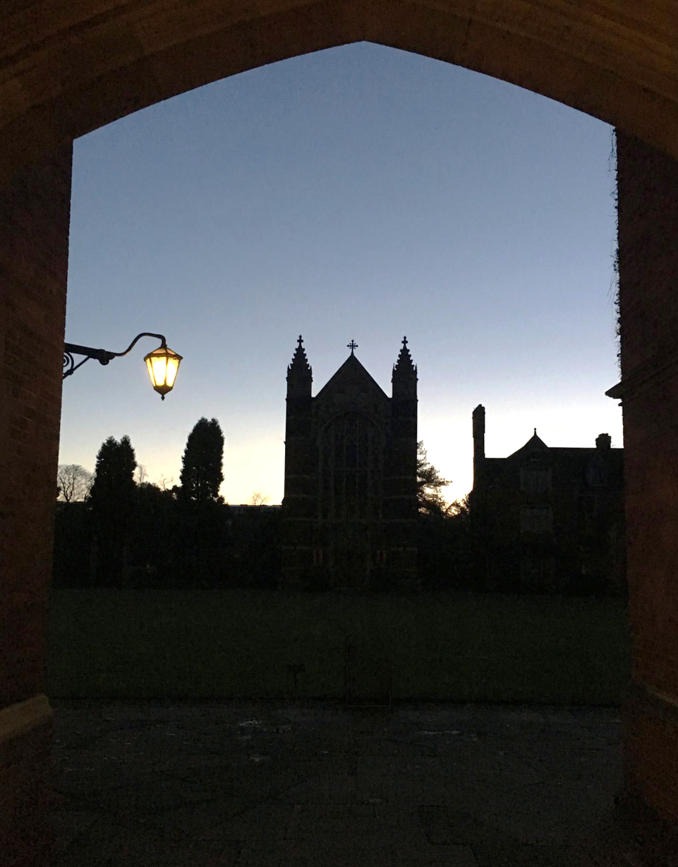

SELWYN COLLEGE CHAPEL
UNIVERSITY OF CAMBRIDGE

MUSIC FOR CHORAL SERVICES
Michaelmas Term 2022

The Rev’d Dr Arabella Milbank Robinson MA MPhil
Dean of Chapel and Chaplain

Sarah MacDonald MA FRCO ARSCM
Director of Music

Adam Field ARCO
Percy Young Senior Organ Scholar

Shanna Hart MA MSci FRCO
Assistant Organist
WEEK 0

Saturday 24 September 6pm
Choral Evensong & Commemoration of Benefactors

Confortare – Dyson Responses: Byrd/SEAM
Wood (SE 1888) in D Psalm 34: 1-11
And I saw a new heaven – Bainton NEH 436
Organ: Elegy – Thalben Ball

Sunday 2 October 5:30pm TRINITY 16
Freshers’ Welcome Evensong

O taste and see – Vaughan Williams Responses: Forbes L’Estrange
Edington Service – Grayston Ives Psalm 119: 33-40
Expectans expectavi – Wood NEH 368
Organ: Fugue on a theme of Corelli (BWV 579) – J. S. Bach

WEEK 1

Thursday 6 October 6:30pm
Choral Evensong

Howard Helvey in B flat Responses: Forbes L’Estrange
Virtue – Jennings Psalm 5: 1-8, 12-13
Organ: Andante tranquillo (Sonata III) – Mendelssohn NEH 431

Sunday 9 October 6pm TRINITY 17
Choral Evensong

O gracious light – Austin Echols Responses: Radcliffe
Sarah MacDonald in A flat Psalm 27
Ecce beatam lucem – Jonathan Dove NEH 247, 427
Organ: Festival Voluntary – Flor Peeters
Tuesday 11 October 6:30pm
Choral Evensong

Fauxbourdons on Tones vii and i – Tallis Responses: Byrd
Beati omnes qui timent Dominum – Lusitano Psalm 86: 1-13
Organ: O Gott du frommer Gott – Smyth

Wednesday 12 October 9:30pm
Choral Compline

Lighten our darkness – Ed Marsh Psalm 31: 1-6
Nunc dimittis Terti toni – Sarah MacDonald
God be in my head – Richard Allain

WEEK 2

Thursday 13 October 6:30
Choral Evensong

Service with Faburdens – June Nixon Responses: Radcliffe
Alleluia Psallat – Aston Psalm 111
Organ: Little Pastorale – Price NEH 240

Sunday 16 October 6pm DEDICATION FESTIVAL
Choral Evensong

He made the stars also – Sarah MacDonald Responses: Rose
Stanford in C Psalm 8
Blessed City, heavenly Salem – Bairstow NEH 477, 205
Organ: Chorale varié sur le Veni Creator – Duruflé

Tuesday 18 October ST LUKE
Choral Evensong

Noble in B minor Responses: Rose
O ye that love the Lord – Coleridge-Taylor Psalm 116
Organ: Prelude and Fugue in D minor – C. Schumann

WEEK 3

Thursday 20 October 6:30pm
Choral Evensong

Fourth Service – Batten Responses: Byrd
Man that art born of a woman – Purcell Psalm 103: 1-13
Organ: Voluntary No. 1 – Cecil NEH 250

Sunday 23 October 6pm LAST AFTER TRINITY
Choral Evensong

Rise up, my love – Willan Responses: Forbes L’Estrange
Sumsion in A Psalm 89: 1-13
The heavens are telling – Haydn SP 239, 248
Organ: Fugue on a theme of Legrenzi (BWV 574) – J. S. Bach

Tuesday 25 October 6:30pm
Choral Evensong

Purcell in C Responses: Smith
This is the Record of John – Gibbons Psalm 28
Organ: Fantasia in Four Parts – Gibbons

WEEK 4

Thursday 27 October 6:30pm EVE OF Ss SIMON AND JUDE
Choral Evensong

Third Service – Philip Moore Responses: Radcliffe
Beati quorum via – Stanford Psalm 27
Organ: No. 2 (Six Short Postludes Op. 105) – Stanford NEH 195

Sunday 30 October 6pm ALL SAINTS’ SUNDAY
Choral Eucharist

Os justi – Bruckner NEH 225 (ii), 478
Collegium Regale – Howells
O sacrum convivium – Messiaen
Organ: Gloria (Missa de Gloria) – Leighton

Tuesday 1 November 9pm EVE OF ALL SOULS’ DAY
Vigil Requiem

Requiem Op. 9 – Duruflé

WEEK 5

Thursday 3 November 6:30pm
Choral Evensong

Selwyn Service – Alan Bullard Responses: Rose
Save us, Good Lord – Iain Quinn Psalm 29
Organ: Domine Jesu Christe – Demessieux NEH 242

Saturday 5 November 5:30pm
The choir sings Choral Evensong at ELY CATHEDRAL today.

Selwyn Service – Alan Bullard Responses: Rose
Ecce beatam lucem – Jonathan Dove Psalm 27, 28, 29
Organ: Prelude in E minor (BWV 548i) – J. S. Bach

Sunday 6 November 6pm THIRD BEFORE ADVENT
Choral Evensong (conducted by Timothy Brown)

and the swallow – Caroline Shaw Responses: Radcliffe
Wood in D Psalm 104: 24-34
O Lord how manifold – Paul Edwards NEH 264 (A&M 116i),
Organ: Fast Cycles – Nico Muhly 263 (omit *)

Tuesday 8 November 6:30pm
Choral Evensong (Tenors and Basses)

Dyson in C minor Responses: Plainsong
Brother James’ Air – Bain arr. SEAM Psalm 119: 73-88
Organ: Elegy – Thalben-Ball

WEEK 6

Thursday 10 November 6:30pm
Choral Evensong (Sopranos and Altos)

Harris in D Responses: Plainsong
For the fallen – Mark Blatchly Psalm 16
Organ: Cantilena – Bate NEH 331

Sunday 13 November 6pm REMEMBRANCE SUNDAY
Words and Music for Remembrance

Tuesday 15 November 6:30pm
Choral Evensong

Third Service – Philip Moore Responses: SEAM
Never weather-beaten sail – Shephard Psalm 18: 20-30
Organ: Jesu dulcis memoria – Walford Davies

WEEK 7

Thursday 17 November 6:30pm
Choral Evensong

Magnificat Primi Toni – Bevan Responses: SEAM
Nunc dimittis – Beach Psalm 24
A good night – Rodney Bennett NEH 245
Organ: Miniature No. 2 – Howells

Sunday 20 November 6pm CHRIST THE KING
Choral Evensong (joint with Youth Consort of St George’s Cathedral, Southwark)

The Lamb – Tavener Responses: SEAM
Wood in E flat no. 2 Psalm 148
A new song – James MacMillan NEH 391, SP 267
Organ: Te Deum – Demessieux

Tuesday 22 November 6:30pm ST CECILIA
Choral Evensong

Worcester Service – Howells Responses: Nardone
A Hymn for St Cecilia – Howells Psalm 96
Organ: Fugue on Gonfalon Royal – Sarah MacDonald NEH 333
Wednesday 23 November 9:30pm
Choral Compline

In pace – Tye Psalm 31: 1-6
Nunc dimittis Terti Toni – Victoria
Usquequo, Domine – Guerrero

WEEK 8

Thursday 24 November 6:30pm
Choral Evensong

Fifth Service – Tomkins Responses: Smith
Vox in Rama – de Wert Psalm 44: 1-9
Organ: Allemande – de la Guerre NEH 499

Sunday 27 November 6pm ADVENT SUNDAY
Procession with Carols

Tuesday 29 November 6:30pm EVE OF ST ANDREW
Choral Evensong

St Andrew’s Service – Aston Responses: Nardone
O Lord, support us – Ben Ponniah Psalm 87
Organ: O Antiphon – Cecilia McDowall

WEEK 9

College Carol Services will be held as follows:
Thursday 1 December 6:45pm
Sunday 4 December 6pm
Tuesday 6 December 7pm
Thursday 8 December 7pm (St James’ Piccadilly, London)

