UK GDPR: Data Consent

Data subjects must give consent for their data to be collected and/or processed.
You must provide clear information on what the data will be used for. Consent must be:
- specific, informed and freely given;
- it cannot be implied;
- the data subject must specifically “opt in”;
- the consent must be for a specified duration;
- when the duration has lapsed, consent must be renewed.
If consent is not given or if it is withdrawn, data must be removed or anonymised.

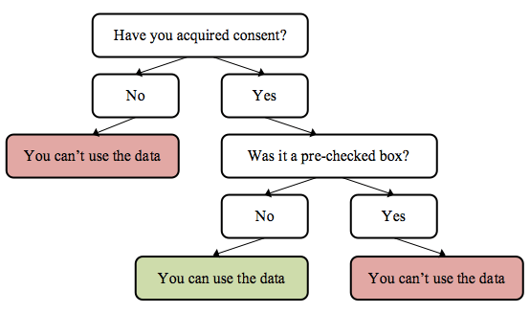

Further information

Refer to the ICO website for more detailed guidance: https://ico.org.uk/for-organisations/guide-to-data-protection/guide-to-the-general-data-protection-regulation-gdpr/individual-rights/right-to-object/

