NEWNHAM AND SELWYN COLLEGES
A free, confidential service
to help improve your writing skills

Students of any discipline, at any level of study (from 1st year to postgraduate) – and staff – are welcome to book a 50-minute session.
The Royal Literary Fund Writing Fellow is a professional, published author whose role is to help you strengthen your academic writing. Sign up for a FREE one-to-one tutorial for advice on:
- planning your study time
- structuring your essay or dissertation
- expressing your ideas more clearly
- sorting out confusion about grammar and punctuation
- discovering techniques for editing and proofing your work
- increasing your confidence in and enjoyment of the writing process

Please note that RLF Writing Fellows do not undertake proofreading or EAP tuition.

Appointments are available on Tuesdays between 11am and 6pm, & Wednesdays between 10 and 5. Some appointments are also available outside term-time. Only book one session at a time.
Sessions are held in college, but you may enquire about an online session if you are away or cannot get to the office (however, you must be in the UK at the time).
To enquire or book your session, email: ruth.martin@rlfeducation.org.uk
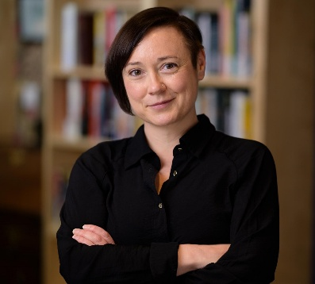
Ruth Martin has been translating fiction and nonfiction books from German since 2010, by authors ranging from Joseph Roth to Angela Merkel. Ruth has also taught translation at Birkbeck, the University of Kent, and the Bristol Translates summer school. Her translation of Shida Bazyar’s The Nights are Quiet in Tehran was shortlisted for the 2026 International Booker Prize.

