Statement of Intent | Selwyn College recognises and accepts its health and safety duties to provide a safe environment (as far as is reasonably practicable) for its staff, students, and all visitors to its premises under the Health and Safety at Work etc. Act 1974, the Fire Safety Order 2005, the Management of Health and Safety at Work Regulations 1999, other relevant legislation and common law duties of care. (Note: For the purpose of this policy, the term “Staff” includes all Fellows, Emeritus Fellows, Bye-Fellows, Lectors, Teaching Associates, Research Associates, Lectors, Workers, Agency Staff and Volunteers.)  The College considers the health, safety and welfare of staff and students to be of paramount importance, and that a safe and healthy working environment is a prerequisite to achieving its commitment to promoting excellence in teaching, learning and research. The College is committed to maintaining high standards of health and safety and to continually improving the effectiveness of our health and safety management system and culture.  The College expects staff, students, visitors, and contractors who work at the College to share this commitment by complying with College policies and procedures, and understanding that they too, have legal and moral obligations to themselves and to one another.  The College intends to ensure the health and safety of all persons who may be affected by its activities by:  - Setting standards that comply with the relevant statutory requirements relating to health and safety of employees, students, contractors, visitors and the public;  - Safeguarding employees and others from reasonably foreseeable hazards connected with work activities;  - Implementing safe systems of work and where there are residual risks to health, these are controlled;  - Identifying hazards and conducting formal risk assessments when appropriate, in order to minimise physical and psychological risks for all activities undertaken by the College;  - Providing, managing and maintaining plant and equipment so that it is safe, so far as reasonably practicable, and that risks to health are controlled;  - Ensuring that when new substances, plant, machinery, equipment, processes or premises are introduced, they are assessed and adequate guidance, instruction, training and supervision are provided and safe methods of work are developed;  - Providing sufficient information, instruction, training and supervision to ensure that staff are competent to undertake their work activities and are aware of any related hazards and the measures to be taken to protect against them;  - Providing, managing and maintaining College properties so that they are safe, so far as reasonably practicable, and that risks to health are controlled;  - Providing adequate and appropriate facilities and arrangements for welfare at work;  - Promoting good health amongst employees concerning the prevention of occupational and non-occupational disorders and diseases;  - Promoting a positive health and safety culture and educating our staff and students in health and safety;  - Communicating and consulting with staff and students on health and safety matters, and securing the co-operation of employees and students in implementing the Health and Safety Policy;  - Keeping up to date with best practice in relation to health and safety and complying with relevant legislation and authoritative guidance;  - Undertaking inspection, audit and review activities to ensure that College objectives for health and safety are met.  The College governs its management of health & safety by:  - Having in place a Health & Safety working group, which includes staff and student representatives, which reports formally to the Compliance Committee, which in turn reports to the College Council;  - Having the College’s Responsible Officer (the Bursar) chair both the Health & Safety working group and the Compliance Committee;  - Setting out the detailed responsibilities of key individuals and groups for health & safety.  The College collects personal data to ensure the health and safety of its staff and others.  This policy has been prepared with the advice and direction of the Health & Safety Working Group, with the intention of supplying essential information and advice for the benefit of all staff and members of the College. It is displayed in all departments and available on the College website.  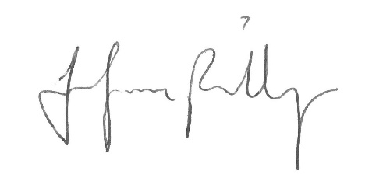  Jennifer Phillips, Bursar  Approved by College Council on 2 May 2023

